***African American Community - Focus Groups Results***

Two focus groups were conducted with African American residents, one group recruited through Monica's Village Place (Monica's) on May 15, 2013 and another recruited through Goodwill Industries on May 22, 2013. This was part of the *Information Technology Access and Adoption in Seattle: Progress towards digital opportunity and equity* study conducted by the City of Seattle. Twenty individuals, both residents of Monica's Village Place and members of the broader community, attended the Monica's focus group and twenty-four attended the Goodwill focus group. In addition, each group included four note-takers/ table facilitators, and an overall group facilitator. Twenty participants from the Monica's group and 23 from the Goodwill group completed at least part of a brief written survey. Participants engaged in planned focus group activities – a dynamic method that relies on *mutual interviewing* among the community members – and did so with evident interest and engagement.

**Table 1. Group demographic description**

|  |  |  |
| --- | --- | --- |
|  | Monica's | Goodwill |
| % women | 72% | 37% |
| Education |  |  |
| Less than high school | 0% | 20% |
| HS grad/GED | 16% | 50% |
| Some college/AA/AS | 42% | 30% |
| BA/BS | 26% | 0% |
| Post grad work/degree | 16% | 0% |
| Age |  |  |
| 18-25 | 5% | 25% |
| 26-35 | 10% | 10% |
| 36-50 | 20% | 30% |
| 51-64 | 40% | 35% |
| 65 or older | 25% | 0% |
| Employment |  |  |
| Employed | 42% | 25% |
| Retired | 42% | 10% |
| Homemaker | 0% | 5% |
| Student | 5% | 20% |
| Disabled | 11% | 10% |
| Unemployed | 11% | 35% |
| Income |  |  |
| <$20,000 | 20% | 79% |
| $20K-$30K | 27% | 16% |
| $30K-$40K | 7% | 0% |
| $40K-$50K | 7% | 0% |
| $50K-$75K | 20% | 5% |
| $75K-$100K | 13% | 0% |
| $100K+ | 7% | 0% |

Table 1 summarizes the demographic distribution of the two groups. Overall, the Monica's participants tended to be older, were more likely to be women, had more education, were more likely to be employed, and had more income than the other group. Both groups indicated diversity of educational achievement. However, most of those in the Monica's group had completed at least some college and 30% of the Goodwill group had completed some college or a two-year degree. More than half of the Monica's group was 51 or older, and more than half of the Goodwill group was younger than 50. The great majority of the Monica's group was either employed or retired, while participants in the other group were more distributed across the employment categories, with about one-third employed or retired and another one-third unemployed. About half of the Monica's participants reported incomes of at least $30,000 per year, as did 5% of the Goodwill group.

**Summary**

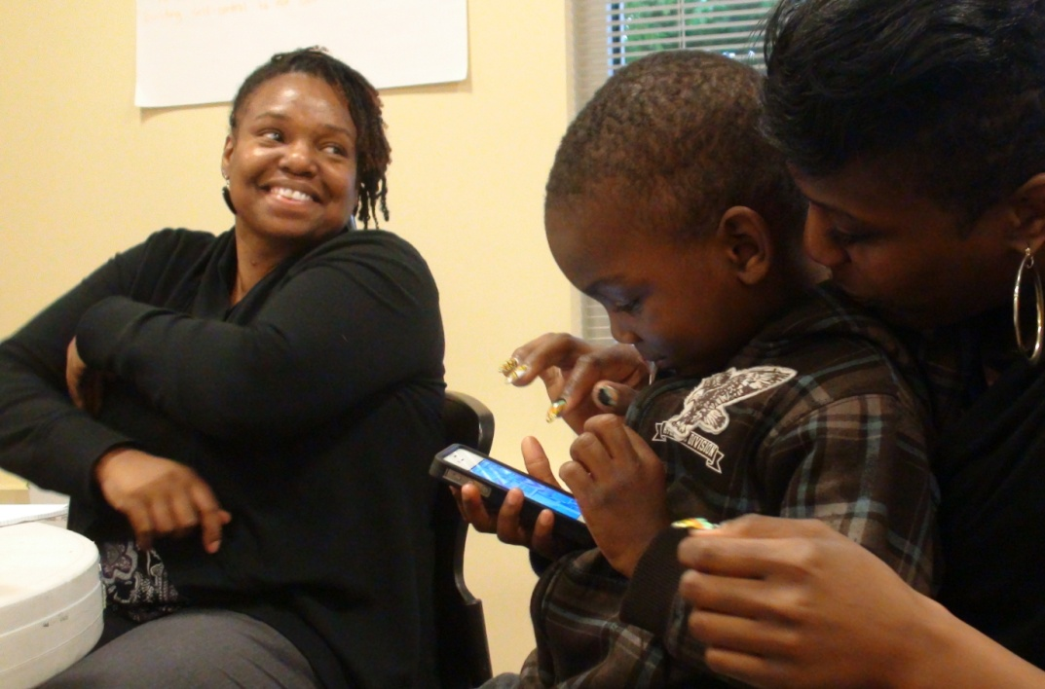These groups differed from one another on several dimensions, and to some extent their opinions reflected these differences. But what they have in common is a high (and increasing) use of technology, including computers and cell phones, and an interest in preserving public access computing. Both groups were pleased to have been given this opportunity to communicate their ideas and concerns, and thanked the City for organizing these sessions. While technology suffuses so much of their lives, and while effective communication to and from the City of Seattle is important to many of these respondents, they were aware of and articulate about both the opportunities and pitfalls associated with the increasing use of technology, and of increasing reliance on social media. The cost of technology use, and concerns about privacy and security were especially prominent, and these discussions surfaced an array of suggestions for the future.

Overall, both groups were enthusiastic about the quick access to information that they can find on the Internet, including information ranging from world events to local communities to personal health. As participants considered higher speed access and the use of social media, especially using social media to communicate with government, they began to express concerns about the security of their personal information and whether using the Internet in this way would increase their exposure to scams, identity theft, and fraud. For some, it also surfaced some hesitance about giving too much personal information to government as a consequence of "friending" government. This concern may be linked to the topic of communication between government and communities or residents. Participants want more engagement and more opportunities to participate, but are not clear how to do that in a way that they know their participation is valued. They suggest building more communication pathways between government and the communities, perhaps through community activities, regular information updates, and more frequent community-level discussions and information-seeking.

While most participants are computer and Internet users, even if their primary access is at the library or community center, some participants are part of an increasingly small population of non computer users. Participants speculate that some non participation may be due to lack of interest, lack of financial resource, or fear of not being able to catch up or keep up. Comment during the focus groups suggest that many of the participants feel uncertain about at least some aspects of technology and when sitting at a table with someone who knew, took quick advantage of their expertise. This experience suggests (1) a need for ongoing training - both to include those who are currently excluded, and to give others a resource to help them keep up with ever-advancing technology and software; and (2) an easy way for residents to find and take advantage of these training opportunities.

**Technology Access and Use**

**Monica's Group:** *Survey* responses show that all Monica's participants have a cell phone - and 65% of those are smart phones. Nearly all (95%) use texting. Only 20% also reported having a landline. Nearly all (95%) have a computer at home (a laptop for 60% and a tablet for 15%) and 85% have Internet access at home. Those that don't have home computers cite financial reasons. *Mutual interviewing* produced similar results. Nearly all (95%) say they use a computer and all use the Internet, half on a mobile device. While the survey responses focused on financial problems with home computer use, the mutual interviewing responses are more multidimensional. This group's report estimates that 20% of the participants do NOT currently have home Internet access or use computers because they are not interested, computers are too expensive, or they just don't want to spend the time to learn and then, keep up. Interviewers also identified possible fears related to lack of privacy or damaging the computer by doing something wrong. It is possible that some interviewees acknowledged that they *can* use computers or have in the past, but tend not to in their daily lives. For example, *survey* results say that almost all (89%) use email attachments. One person indicated in the survey that he doesn't use computers, yet he noted that he has researched health information online and would like to use a computer to do more.

Respondents were given a list of possible ways they might use computers and the Internet. This group checked an average of six different uses, illustrated in Figure 1a. The most common uses have to do with finding information - and note the high level of interest in finding information about the community and about local businesses and health issues. More than half the respondents also use the Internet for shopping.

*Interviewers* asked interviewees what they most like about using computers and the Internet. Most (80%) mentioned access to information with three sub themes related to that access: freedom, speed, and convenience. Though we did not explore the theme of freedom during the group, it seemed related to the apparently unconditional availability of any information without limits imposed by others.

**Like about using computers and the Internet**

* Freedom of access!!
* View of whole wide world
* Being able to post pictures, email, improve education, know how, can pay bills.
* Access to information without leaving home.
* I learn lots of things I wouldn't otherwise know - get an education.
* Access to any information in real time.

Most participants get their home Internet via cable (56%) and a sizeable minority through DSL (28%). Only 6% noted having a data plan for their smart phone.

Figure 2a shows that these participants also use computers at other locations, most notably at work (58%). From the *mutual interviewing* results, public computers and Internet access is very important to these respondents: 80% report using computers at a community center, a library, a computer lab or at a friend's or relative's house.

When asked in *mutual interviewing* about their experience using the computers away from home, most described positive aspects of the experience (high speed, less threat to personal security, more relevant information, more privacy, fewer pop-ups), and a few described negative aspects (inconvenient, not always available). (See box to the left.) About three-quarters agree that the range of opportunities for access available to them is enough for their needs. Some participants used this question to ask for lower cost Internet access.

**Using computers away from home**

* Most of the other computers don't have all the pop ups and slow service as home system.
* They have high speed Internet
* Get more information (unemployment office) that's specific to my needs.
* No threat of being intruded upon.
* (Library) You have to know what you're looking up.
* Inconvenient at times because it's someone else's.

When asked in the survey about their satisfaction with different aspects of their home Internet service, most respondents were satisfied with the reliability (94%), speed (79%), and customer service (71%) associated with their Internet service, but only about one-third (35%) were satisfied with the cost. Correspondingly, they most frequently reported that a lower price would improve their Internet service (68%), followed by speed (50%), and reliability (29%). As has been evident across our data sources in this research, relatively few people were concerned about customer service (20%). *Mutual interviewing* confirms that most participants (89%) say that their home Internet is good enough for them, with a few asking for faster access. When asked on the survey how much they would pay for Internet service or, in most cases, for *faster* service, 95% were willing to pay something. For some, this is very little more (11% less than $5), for others (32%) between $5 and $10; for another 11% between $10 and $20. Some were willing to pay $20 per month or more (32% between $20 and $30; 11% more than $40 per month).

**Problems using computers or Internet**

* I'm not really computer savvy. I use it for the basics. I'd like to learn more.
* I don't have the patience to navigate my way through unfamiliar sites. And there's not enough privacy on specific sites.
* Learning how to master the use of the latest software and innovations.
* Sometimes verifying information and also privacy.
* Navigating software, managing what I do, and keeping up.
* [Need help with] Word, Excel, some computer basics.
* Frequent changes are frustrating to navigating.

When asked how skilled they are with computers, about one quarter rated themselves as "skilled" or "expert." Most often (42%) respondents rated themselves in the middle of the scale ("Can figure out new programs as I need them") and about a quarter rated themselves with less skill ("I know what I need to know" or "None or not very"). About one-third told their interviewer that they do have some problems using computers or the Internet, such as needing more basic skills, tips for navigating through unfamiliar or frequently changing sites, and just keeping up.

Figure 3a summarizes survey responses about why participants' believe they or others do not use computers or the Internet. The most common reason selected is that some people just don't want it or need it, followed by concerns about computer-related security and the cost of Internet service.

*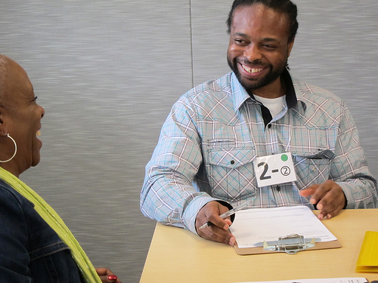***Goodwill Group:** *Survey* responses show that nearly all (95%) Goodwill participants have a cell phone, though less than half as many (one-third) as at Monica's have smart phones. Half of these respondents text. Like Monica's, about 20% of these respondents also have a landline. About half (56%) have a computer at home (a laptop for 41% and no tablets) and 64% have Internet access at home, perhaps through a smart phone for those without a home computer. In the m*utual interviewing* some respondents said they are just now learning how to use their computers, and others said financial challenges prevented their having computers. In the *survey,* about two-thirds (65%) say they use a computer and 70% use the Internet, about half of these on a mobile device. Most (60%) use attachments to their emails. This group selected an average of three uses for computers and the Internet, illustrated in Figure 1b. Participants use the Internet primarily for getting information, including information about local businesses and the community. About one-third use the Internet for online shopping. The *mutual interviewing* group report out also mentioned the use of the Internet to get travel information and the opportunity of using the Internet to help write the people's history and in so doing, influence how history is understood in the future.

*Interviewers* asked what their interviewees liked best (or would like) about using computers and the Internet. Nearly all mentioned having quick access to information, education, and/or news. Several people also specified access to entertainment, and communication. When interviewers reported back to the group, several of the issues raised related to privacy and security of their personal information on the Internet, with specific fears about hacking, identity theft, and fraud.

**Like about using computers and the Internet**

* Because it opens me up to a lot of the world.
* Stay aware of global behavior.
* It helps me educate myself, plus can play games, movies, etc, etc
* Bank account, financial, business, email, job search, Facebook, Google info
* Cost efficient; cuts down on traffic; email
* The net is good for everybody to learn about the world and people in the world.

**Public Access Sites & Where Computers Are Used**

As in the Monica's group, public access computing is important to these respondents: Figure 2b below shows that the library is an important computing resource for nearly two-thirds of this group, second only to home use. When *mutual interviewing* combined library, friend's or relative's, and community technology center, that figure increased to 80%. Interviewees report a generally positive experience at these locations. On the positive side, interviewees note that these computers are available and bring the many benefits of access to computers and the Internet (knowledge, ability to research), and the opportunity to meet new people. One quarter of the interviewees voiced concern about the time limit at the library, and one noted having to make an appointment the use the library computers. Other challenges include a lack of privacy, either no printing available or a charge for printing, and no downloading allowed. For about half, this access is not enough for their needs. Some asked for more time at the library, others asked for lower Internet rates at home, and others asked for free, personal, step-by-step instructions.

Of those who have home Internet access, 77% get it through the cable company and 15% through a smart phone data plan. None of these respondents are DSL customers.

**What more is needed?**

* Sometimes it's too much to keep up with technology.
* Yes, but I need more tutoring and knowledge.
* Not as private like at home; improve on the rate on the Internet.

When asked about their satisfaction with their home Internet service, nearly all (92%) were satisfied with the Internet's reliability, and about two-thirds were satisfied with the speed and the customer service. About half (54%) were satisfied with the cost. Participants were evenly split between speed (50%) and price (50%) when choosing the one thing that would most improve their Internet service. A few also selected customer service (15%) and reliability (8%).

*Mutual interviewing* revealed that overall, 88% find their home Internet to be good enough. However, some mentioned that it can be difficult when many family members all compete for time on one computer. In response, some access the Internet through their Playstation or X-Box. When asked how much they would pay for service or for faster service, one third said "Nothing." Nearly as many (30%) said they would pay between $5 and $10 per month. Nearly a quarter (22%) selected at least $30 per month.

When asked how skilled they are with computers, about one quarter rated themselves as "skilled," but even more (62%) rated themselves as "None or not very" (29%) or "Know what I need to know" (33%). Thirty-nine percent told their interviewer that they have some problems using computers or the Internet, adding that they are still learning how to use it or that they need to improve their skills. Some respondents, but fewer, noted problems like slow connections and viruses.

Figure 3b shows the reasons these participants believe that some people don't use computers or the Internet. Forty-one percent believe that some people just don't want to use it, and as many think that people might want to use it, but the cost of the computer or the cost of the Internet service is a barrier.

**High Speed Internet**

These sessions included the opportunity for the City to talk about the potential and possible availability of super high speed Internet in Seattle, and some of the participants discussed the pros and cons in detail.

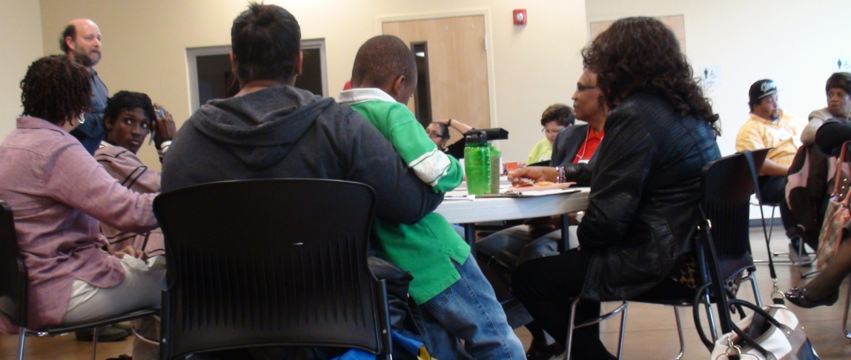**Monica's:** About two-thirds of the participants in one active group was positive about trying this service *and* 71% were concerned about privacy and security of their personal information, particularly at a time when at least some participants expressed a lack of trust in government. It seems that consideration of super high speed access surfaced participants' concerns about the unknown risks of participating in the Internet, and how those risks might be greater with higher speed. Interestingly, despite written notes to the contrary, interviewers perceived that the majority of participants would *not* try super high speed Internet because of the notion that it does not really offer anything new, except for enhanced threats to security as it takes away from human-to-human interactions. Some participants asked for more information about the topic of risk to be able to separate actual risk from fear.

Though some were interested in the possibility of keeping an eye on things at home, participants more often voiced concerns about government or others being able to keep an eye on *them*. Some (19%) expressed concern about cost, including a lack of trust related to cost. Potential applications were wide ranging, including education (14%), medical appointments (14%), attending meetings or events remotely (14%), getting information, including government information (14%), and paying bills (10%). Some (14%) voiced their concerns about losing human contact with one another. On the other hand, participants were positive if it meant that their sick child could still attend school, or being able to monitor home could somewhat replace the neighborhood watch that is no longer active. One person wondered how the city got in the business of asking this question.

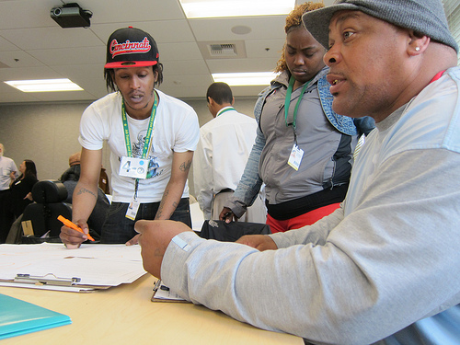**Goodwill:** All the participants had interest in trying possible applications using faster Internet, including medical appointments (35%), keeping an eye on things at home (30%), interactive online learning (25%), and getting information even faster (15%). Fifteen percent of the participants mentioned that they are still learning about these technologies, and would need help learning more. Thirty-five percent expressed concerns about the cost and 35% mentioned a concern about security and privacy.

**Cable TV and Video Content**

**Monica's:** Forty percent of these participants subscribe to cable TV. Most (85%) are satisfied with its reliability, 60% are satisfied with customer service, and only one-third are satisfied with the cost. When asked what one thing would most improve their cable service, nearly all (92%) of the survey respondents checked price. In addition, half checked customer service and half, reliability.

Respondents were asked to rank a number of choices for getting their video content.

* Cable was the first choice for 65% of the respondents, and the second choice for another 5%.
* Internet programs such as Netflix and Hulu were the top choice for 20% of the respondents and a later choice for another 15%.
* Free TV was the top choice for 15% and a later choice for another 15%.
* Satellite was the top choice for 15% and a later choice for another 5%.

**Goodwill**: Thirty-six percent of these participants subscribe to cable TV. Nearly all (91%) are satisfied with the reliability of their cable service, 58% are satisfied with the customer service, and only 36% are satisfied with the cost. When asked what one thing would most improve their cable service, two-thirds named price; 44% named customer service, and 20% named reliability.

Asked to rank a variety of choices for getting video content, respondents' top choice was cable TV (55%), with another 5% ranking it second. Free TV got the second most top ranks (36%), with another 14% giving it a second or third rank. Internet programs such as Netflix and Hulu did not get as many top ranks (32%), but combined with second and third ranks (23% for a total of 55%) they may have more customers than free TV and may present a threat to cable's market share. None of the respondents ranked satellite as their top choice; satellite was the second or third choice for 14% of respondents.

**Seattle.gov and the Seattle Channel**

**Monica's:** Most (71%) of these participants have visited Seattle.gov and 60% have seen the Seattle Channel. Nearly all of those who have seen it (92%) have watched it on cable or on both cable and the Internet.

**Seattle Channel and Seattle.gov**

* Talk about the real problems in the communities
* More people of color or of power, show how to educate people struggling, especially legal, financial, political
* Employment, healthcare, childcare, education, basic info for living.

In *mutual interviewing*, 25% of participants asked for some way to know what will be on the Seattle Channel, 19% asked for information about jobs, 25% asked for information about the local community, the real issues, and a way for the local community to be heard. Thirteen percent would like it to provide information about City resources, what the City has to offer, and City involvement.

Participants asked that the Seattle Channel provide information on each community and some reported that they want the Seattle Channel to be "more interesting." One person said, "What would make me want to visit more often? Nothing! It's not that entertaining!" They also suggested a feature for Seattle.gov where they could enter a ZIP code and get information relevant to that ZIP code. Participants suggested a clear menu of topics on Seattle.gov.

**Goodwill**: Fifty-eight percent of these participants have visited Seattle.gov and 47% have seen the Seattle Channel. Almost all (89%) of those who have seen it, have watched it on cable.

In *mutual interviewing* participants mentioned some topics that would make them more interested in communication from Seattle, via the Seattle Channel or Seattle.gov. One-third mentioned information related to jobs (perhaps teaming up with other departments or agencies to provide labor outlook information and resources); 18% mentioned an interest in education (perhaps using the resource to help residents find computer training or generally navigate the City's multiple educational resources); 15% mentioned an interest in current events, including a discussion of the real issues the City is facing; 10% would like to have more information about parks and recreation.

**Social Media**

**Like and dislike about social media**

**Like**

* It keeps me in touch with family and friends as well as events in my 'hood and special shows and maybe music. Also share with friends.
* Facebook - check in on friends - nosy; Twitter: follows some people; LinkedIn - colleagues from school and employment

**Dislike**

* too much info, security!!!
* the constant changes with technology. Privacy issue that change with other changes.
* doesn't like to have to look every day. It's taking away from our ability to communicate on a personal level
* I still have to learn something new and the changes are annoying - it's a full time job!
* All the info is out there on Facebook so he has a fear of giving out his personal info online. From all the scams and identity theft or phishing. And there are fears of fake people. If someone is computer illiterate they might have fears of never being able to learn the whole computer functions.

**Monica's:** One of the *mutual interviewing* groups explored the use of social media among the participants. Eighty percent of the participants said they use a social networking program, and *all* of them named Facebook. Forty-four percent also mentioned LinkedIn and the same percentage mentioned Twitter. Of those who don't currently use a social networking program, one-third wants to. Those who don't use it or don't want to mentioned concerns about security, the intrusiveness of the program, and the lack of a paper trail (for proof) when communicating in an official capacity, again, raising the issue of trust.

The *survey* asks how often they use email, Facebook or Twitter. Of the three platforms listed, email is the most commonly used, checked daily by 75% of the participants and not used by only 5%. Facebook was not far behind, with 63% checking it daily and only 11% not using it at all. Twitter is not used at all by 65% of this group and checked daily by 6%.

In *mutual interviewing*, participants said they like to use their social networking program for:

* communicating with other people (88%)
* keep up with news and local events (31%)
* study or learn (19%)

Participants also expressed a variety of concerns with using social media:

* security, privacy concerns (50%)
* too much information (25%)
* negative comments, fighting (19%)
* frequent changes (19%)

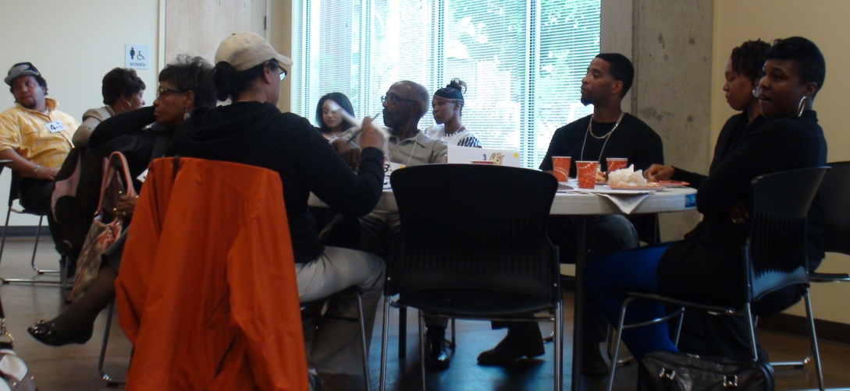Interviewers explored the possibility of using social media to communicate with government. Participants were largely, but not entirely, negative about this idea. Half of the respondents mentioned their concerns related to security and privacy. Some of these were explicitly concerned that communicating with the government via Facebook would give the government access to their private information. An additional concern was that their private information would then be shared without adequate controls. Some participants were concerned about the "dinosaurs" who are not online and thus would be excluded should the City move to an entirely electronic approach to communication. In a statement of resistance to this outcome, one person exclaimed, "I'll hold on to my eight-tracks forever!" One suggestion participants offered to avoid excluding the "dinosaurs" was to be sure that news reporters know when a Facebook announcement is released, or announce it via email.

**Goodwill:** In*mutual interviewing*, 41% of the participants said they use a social networking program, mostly Facebook, with a few also mentioning Twitter. Of those that don't use it, 31% want to. Forty-two percent of those that don't use it say it's because they don't know how or don't have the necessary equipment and as many are not interested. A quarter are concerned about security and privacy.

**Like and dislike about social media**

**Like**

* For social visit and looking at new things, movies, job search, educational videos, to read, video, learn from Google, what's new
* get point across to mass public in a short amount of time
* social networking. keeps me in touch with friends and family. Brought old friends back into my life.
* To keep track of what is going on

**Dislike**

* Maybe. Don't have a computer and don't really care about Facebook. To me Facebook is for the younger generation
* Time consuming, not too familiar with computers
* Superficial lifestyles and distractions
* When people are always on their phone.
* There is a lot of drama involved

According to the *survey*, almosthalf (44%) of this group checks email daily and another 31% check it a few times a week. Thirteen percent don't use email at all. Almost one-third (31%) say they check Facebook daily or a few times a week (19%). Thirty-eight percent don't use Facebook at all. Twitter is not used at all by 75% of this group and not checked daily by any.

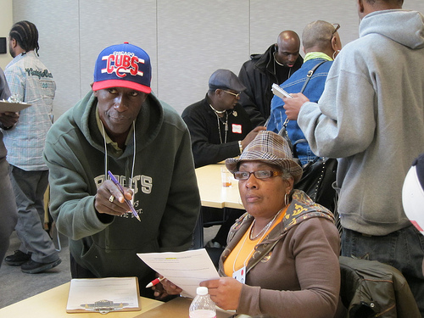In *mutual interviewing*, participants said they like to use their social networking program for:

* communicating with other people (88%)
* keep up with news and local events (25%)
* study or learn (25%)

Interviewers explored the possibility of using social media to communicate with government. Participants were largely positive about this idea - 83% said they thought it would work to communicate with government in this way. Twenty-two percent did not like the idea, some because they lack trust in government. A few (13%) were concerned for the security of their personal information and 9% expressed concern about those without computer or Internet access or knowledge. Nearly all (85%) of those who don't use social media said that if the City starting putting information out over the Internet, they would consider starting to use it to stay informed - but they might need help learning how to do it.

**Comments about social media and government**

* It is good and important for all age groups to understand what's happening in our lives
* It's a good idea, provides information through social media, covers important topics about community
* I use it for fun. Don't like the government invading my privacy. That will steer me away. Government jobs are OK to post.
* Good. Most people get their info this way. Plus it's good for senior citizens. The more I learn the more advantages I'll have
* Pro - it's a great idea. It is much easier to get info from the Internet. Con - too much junk mail
* It will touch a lot of people who don't have transportation or a lot of networking skills. Cons: putting the information out to strangers
* it works for employment, but not comfortable for personal
* By the City taking this action it increases involvement with the people which are most important.
* I am not going to accept the government as a "friend."

**Communicating with Government**

**Monica's:** In a more general question about communicating with government, survey respondents were asked to check as many boxes as they wish to indicate how they would like to give opinions to the City on issues they care about. Figure 4a below illustrates the pattern of responses with "email or online survey" the most commonly selected response (74%) and "in person focus group" not far behind (68%). About one-third each selected a community or city-wide meeting, discussion on the Internet, or a telephone survey and nearly as many (26%) selected "call in to a meeting."

In another question about making contact with government, email was also most often selected as the preferred strategy (78%), followed by telephone (33%), in person or letter (both 28%). Facebook or twitter was next at 22% and text last at 11%.

Participants had many suggestions for how the City could do better in getting information out to communities and making it easier for residents to participate in improving their communities.

Overall, participants want a way of knowing what is coming up, by using mailings, the media, or the Internet. They want to know on a regular basis (weekly) about projects planned, when meetings are scheduled, ideas for community improvement. They want the information in plain English so it is easy for residents to understand. And they advise the City to work to get feedback from the community more often.

In *mutual interviewing*, more than half of the respondents suggested giving their opinions through some type of direct community contact, including a focus group (32%), a community meeting or in person (each 11%) or "direct contact" (21%). Surveys and email were both mentioned by 21%, letters and phone calls by 16%. This group's report included the additional suggestion of offering focus groups during the day for seniors who are available and don't like to come out at night. They also emphasized the importance of residents having access to City Hall without an appointment and some way of getting quick and reliable information on things that change frequently in government.

The survey offered a list of possible ways to get information they care about from the City and participants were allowed to check any that would work for them. Figure 5a shows that most people in this group want to get their information from the City via email (68%) or TV news (63%). More than half asked for a notice in the mail (53%). Overall, 90% selected some Internet-based communication strategy, including email, the City's website (37%), or Facebook (32%).

**Goodwill:** The Goodwill participants also were most likely to select "email or online survey" as a way they'd like to give their opinions to the City, followed by "telephone survey." One quarter each selected "community meeting" and "in person focus group." Nearly as many (20%) selected "Facebook" or "text." Figure 4b illustrates the pattern of responses to all the options. None of the participants prefer *not* to give their opinions. In *mutual interviewing* 22% suggested group meetings and the same number mentioned writing a letter. Seventeen percent each mentioned completing a survey, going to City Hall in person, or sending an email.

Participants had many suggestions for how the City could do better in getting information out and making it easier for residents to participate in improving their communities. Participants suggested many of the strategies already considered (Facebook, Twitter, email, news) in addition to some new ideas (YouTube, billboards, flyers or brochures). Participants want contact with City representatives, asking for a community picnic or other activities that make it possible to develop relationships, and, as one participant put it during the discussion, "Let us feel your heart."

When asked how they prefer to make contact with the city, "email" was also selected by 45%, as was writing a postal letter. Twenty percent each selected telephone or in person, and fewer than 15% selected Facebook/Twitter, or text. In the ensuing discussion, participants urged the City to pay attention to the subject line in order to avoid getting deleted instead of read. They suggested being clear about the topic and particularly making it clear that it is something the residents will *want* to look at, such as "Good News," or "Important information," or "The thing you need to know because we care."

**Communication with the City**

* Come out more; do community activities.
* Have a picnic for community
* They can give out free bus passes monthly. Community action meetings - reform groups, church.
* By posting billboards and making announcements for my community to get involved.
* Use everything to transmit information, especially for elders who may not be literate.
* Give more information about how to be involved. So people know their perspective will be important.

Participants selected from another list how they would like to get information *from* the City, illustrated in Figure 5b. The clear preference for this group is via the TV news, selected by 80%. The nearest second option was by text (35%).

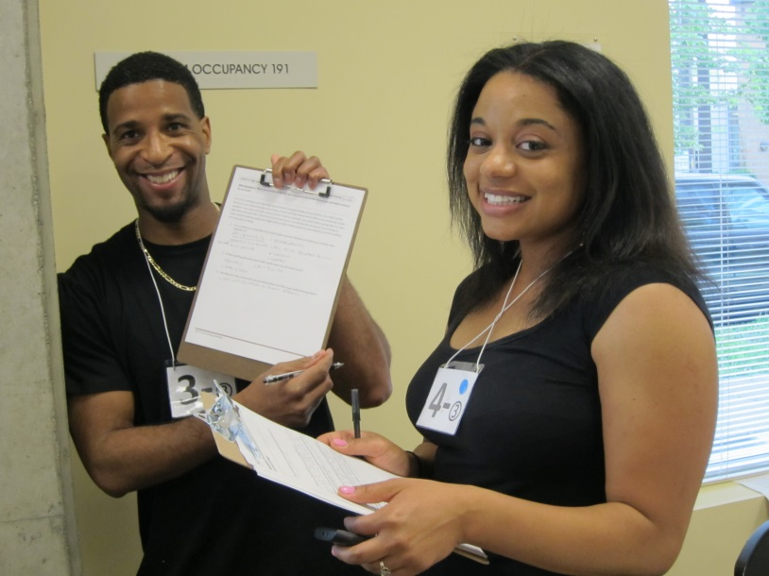

**Communication with the City**

* The City should have a comments section from each department on the website. For example, if you have a comment about a public utility have a section for that on the webpage.
* Public forums, small groups so opinion is heard.
* The City should do more community outreach (like tonight).
* Get people involved through events (with food!) Be on Facebook.
* Communicate through mail and come up with better ideas. Communicate more.
* Quarterly focus/ direct contact.
* Focus group, invitation to dialogue
* I prefer to get my info in the mail from Seattle. Something in my hand. I'll just breeze through it if it's online.
* Just place an ad on the news. If something pops up in my email, I don't think it's real. I’m more likely to open it if I know it’s coming.
* We have a lot of information on our areas and if no one comes and asks, how are they going to know it?

**Learning**

**Monica's:** In *mutual interviewing*, 63% identified computer- and Internet-related topics they'd like to learn more about, including more about social media (21%), privacy and security issues (16%), and for some (11%), some basics. This group's report out added:

* how to back up information
* privacy
* how to set up your own home wi-fi networks that is secure and doesn't leak personal information (like social security number)
* computers and the Internet, in general

Participants were diverse in their preferred learning environments with 42% each selecting short workshops and individual training, followed by classes 32%, and videos (26%). The group's report out also featured a request for "hands on" learning opportunities.

**Goodwill:** In *mutual interviewing*, 83% of the participants said they are interested in various forms of learning. About one-third asked for help in learning to use computers and the Internet. Other topics were spread out, including social media (9%), specific programs (Microsoft Office) (9%), how to create a website (9%), the internal workings of a computer/ how to build a computer (13%), information about security and privacy with the Internet (13%), graphic design (13%), and 5% each for how to search for a job online, benefits, how to create an app, and one person asked for "everything."

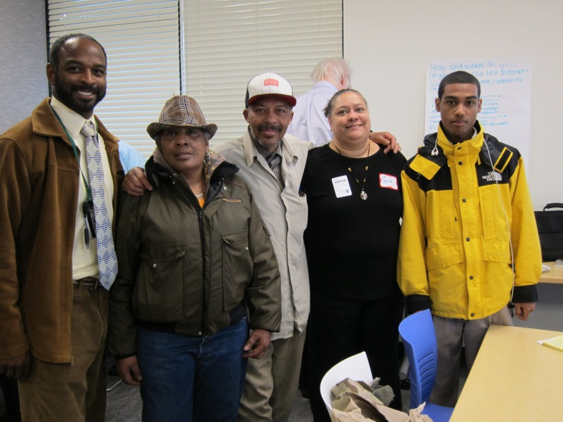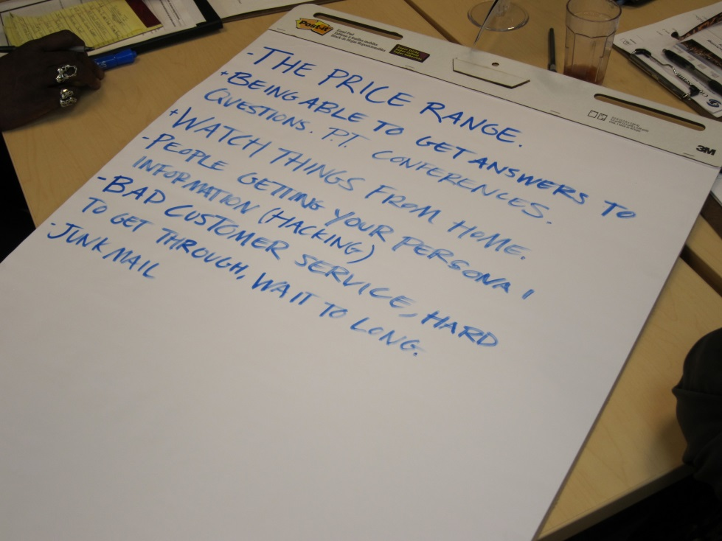Participants were varied in preferred learning environment with 41% selecting classes, 32% asking for individual training, 27% suggesting videos, and 18% mentioning workshops. Some specified the importance of "hands on" learning.

|  |  |
| --- | --- |
|  | See the full report with other focus groups and survey results at Seattle.gov/tech/indicators   City of Seattle Department of Information Technology  Community Technology Program |

**Learning**

* More about privacy, where does the info go? Does IRS, CPS, the Feds see it? For real - no joking!
* How to manage and navigate. If I knew more, I'd do more.
* How to get info out - from a developer's perspective. How to target certain demographics and neighborhoods on Facebook.
* There were a couple that are not too savvy and don't know how to put up their own network or clean up their hard drive or delete old emails. There were two computer wizards at the table and there were several questions being asked right away to help us all understand.
* People said they want a better resource on how to go to classes and where to go if they don't have money. Hands on.